Statistical Analysis of Economy and Policy Seminars (EPS)
2015-2018

Ali Cevat Taşıran

February 2019

We started the EPS Series on 21st October 2015. The latest seminar day was 26th December 2018. After 3.5 years, we had altogether 84 paper presentations. During this period, total 2924 persons participated in the seminars. It gives an average of 35 (median of 25) for each seminar.

Introduction

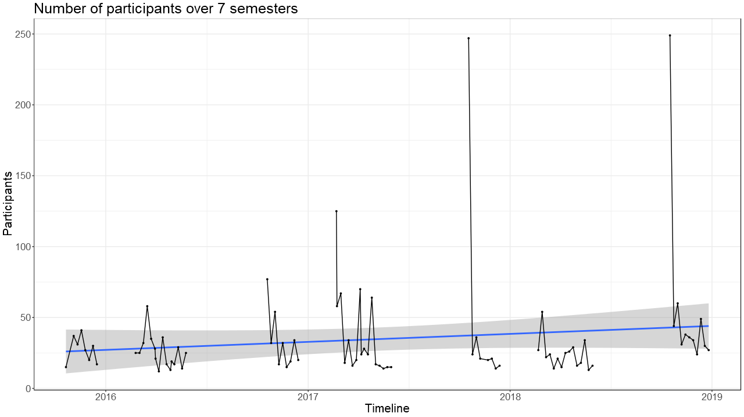
Figure 1. Number of participants over seven semesters

Figure 1 shows the number of participants in the last seven semesters. The breaks in between the lines indicate winter and summer breaks, in that cyclical order. The blue line in the middle is the non-parametric LOESS (locally estimated scatterplot smoothing) linear regression line, which seems to have a positive slope, meaning seminar participants on average, has been increasing over time. Most semesters either began with a highly attended seminar or had one such seminar within the first three weeks. Afterwards, a decline is seen in all semesters.

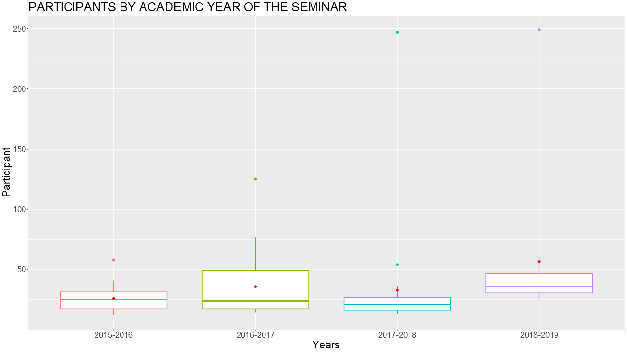
Figure 2. Seminar participants by academic year

In Figure 2, the distribution for each academic year is shown. The red diamonds are the arithmetic averages. As can be seen, 2016-2017 has the most inter quartile range, while 2018-2019 has the most minimum value, meaning last semester had on average more participants than before. This can be attributed to the student participants keeping their friends in check, going to events together and encouraging each other.

Sexes of the speakers

Meanwhile, only 23 of the 84 seminars had a female speaker. While male speakers garnered 2266 participants, female speakers only reached 658 people over the course of 3.5 years. This means on average 28 people attended female speakers’ seminars, while male speakers saw on average 37 people. This is partly due to the most attended 3 seminars being given by men. If those outliers are removed, male speakers on average have also had 28 people attend. But still there’s a discrepancy that can be seen in the following graphs:

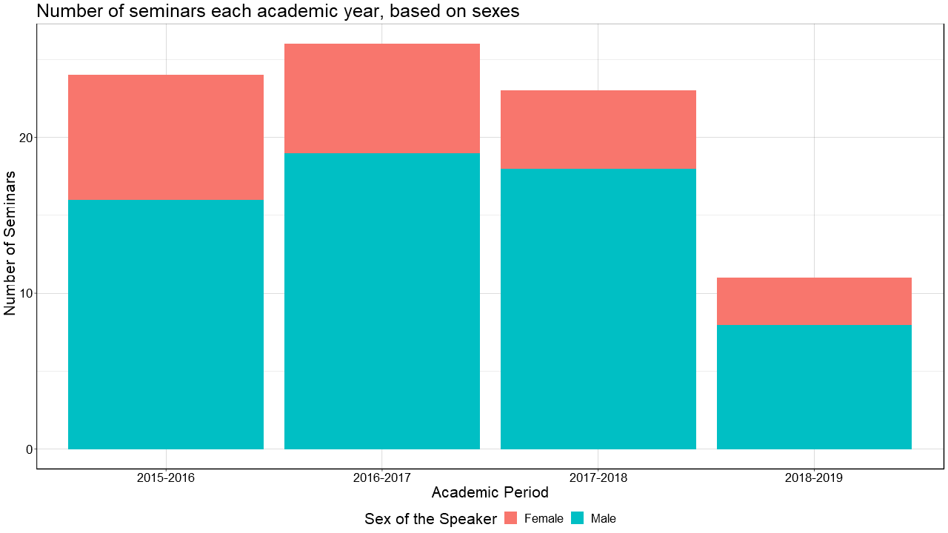
Figure 3. Seminars each academic year, based on the sexes

In Figure 3, each academic period has had more male speakers than female, but more strikingly, the number of female speakers is decreasing each period as well.
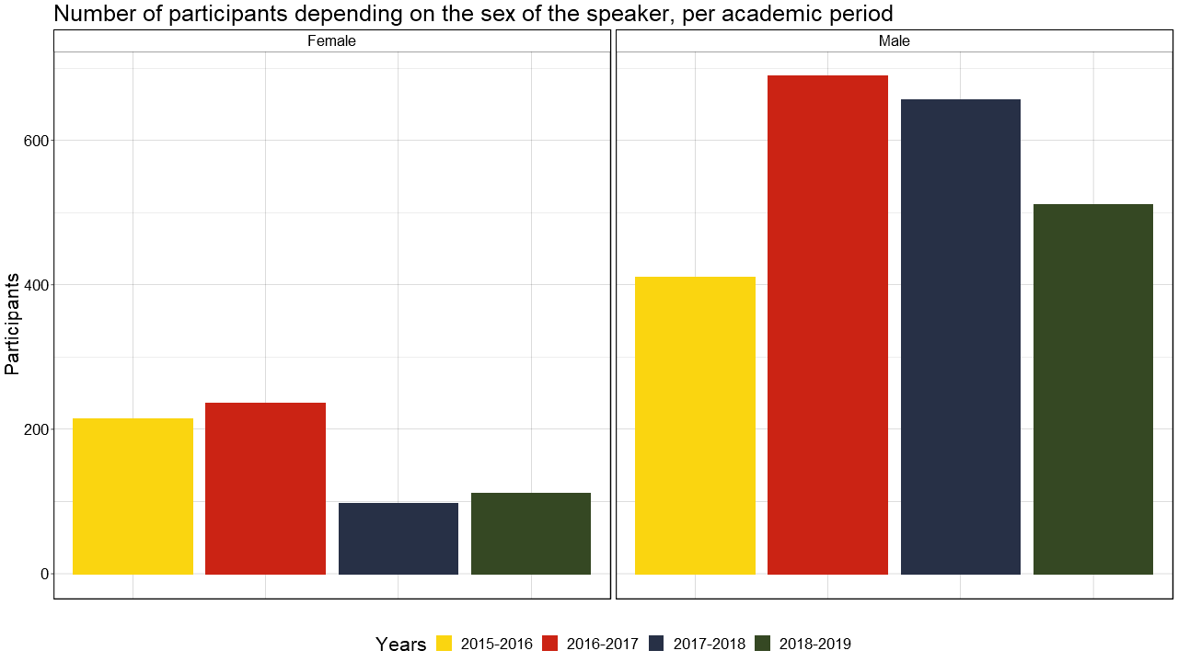
Figure 4. Number of participants depending on the sex of the speaker, per academic period
Figure 4 shows the number of participants each sex garnered over four academic periods. Men also have more participants overall than women.

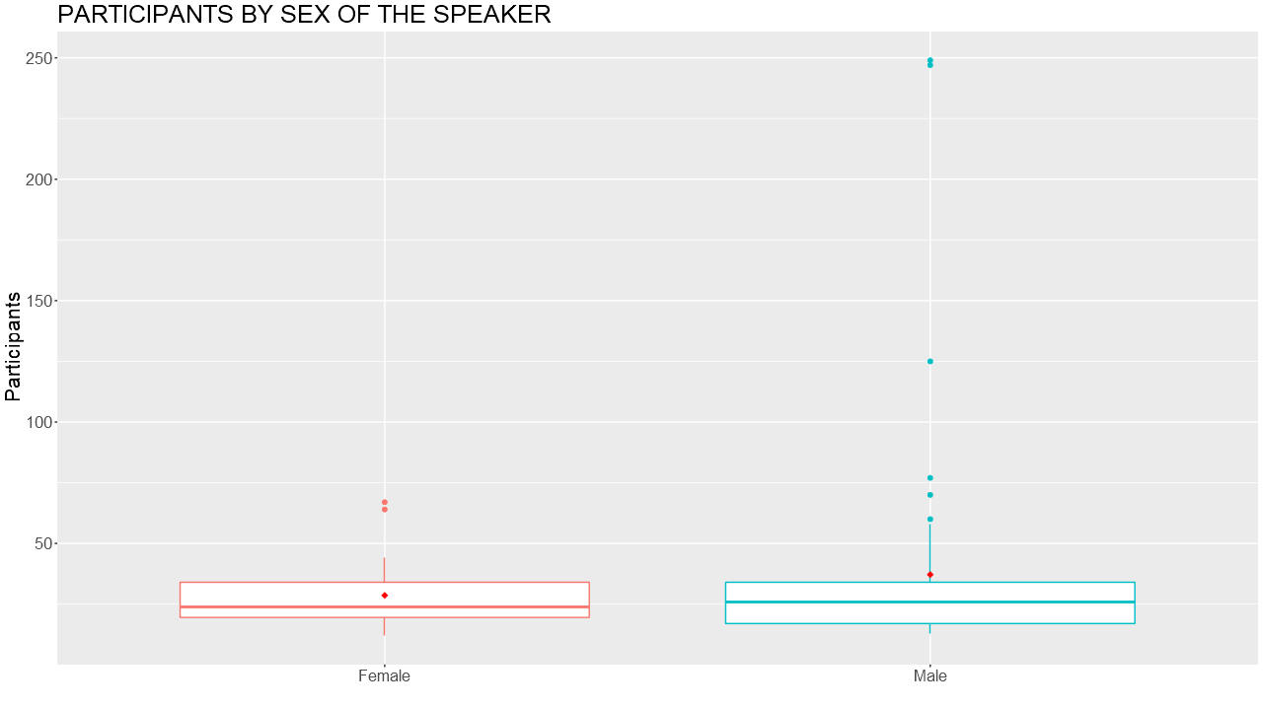
Figure 5. Participants by sex of the speaker
Figure 5 shows the distribution of participant numbers based on the sex, and red diamonds indicate the arithmetic mean. The line in the middle of the box is the median, which shouldn’t be affected by outliers. But even the median participants of male speakers are higher than female speakers’ median.
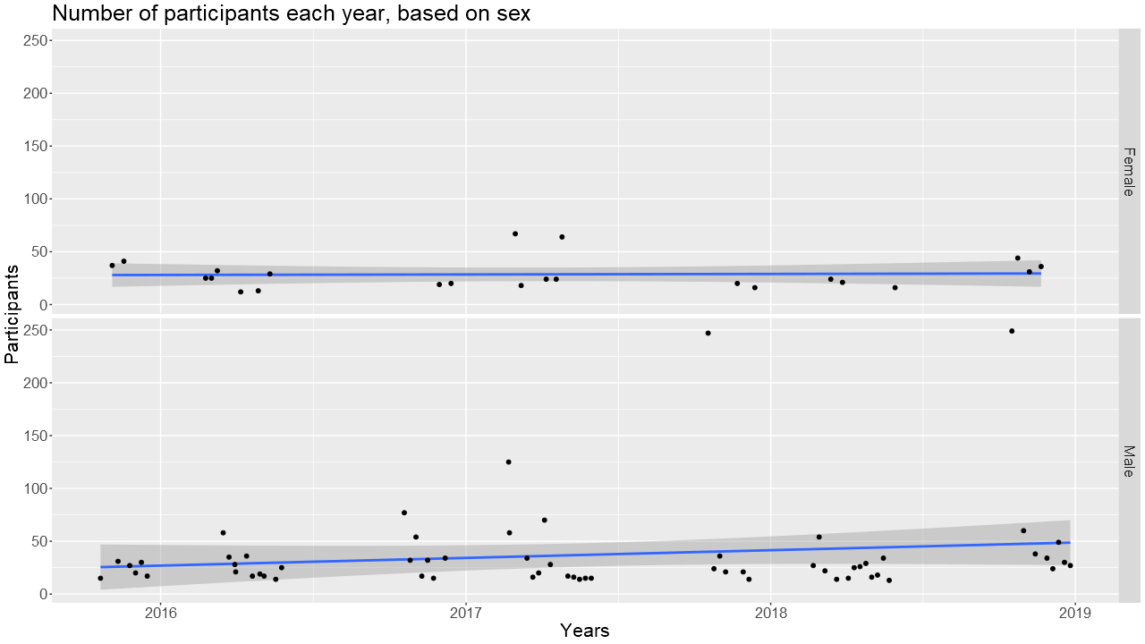
Figure 6. Number of participants each year, based on sex
Figure 6 shows how many seminars were conducted both by men and women, and at the same time the participation each received. The blue lines are the linear LOESS regression estimates of the trend.

Languages of the seminars

If we were to look at the language of the seminars, 20 out of 84 were held in Turkish, while 60 were held in English. 1252 people attended Turkish seminars, while 1672 people attended English seminars. This means on average 62 people attended Turkish seminars while 28 people attended English seminars. Again, the numbers on the Turkish side were inflated by the three of the biggest seminars being held in Turkish.

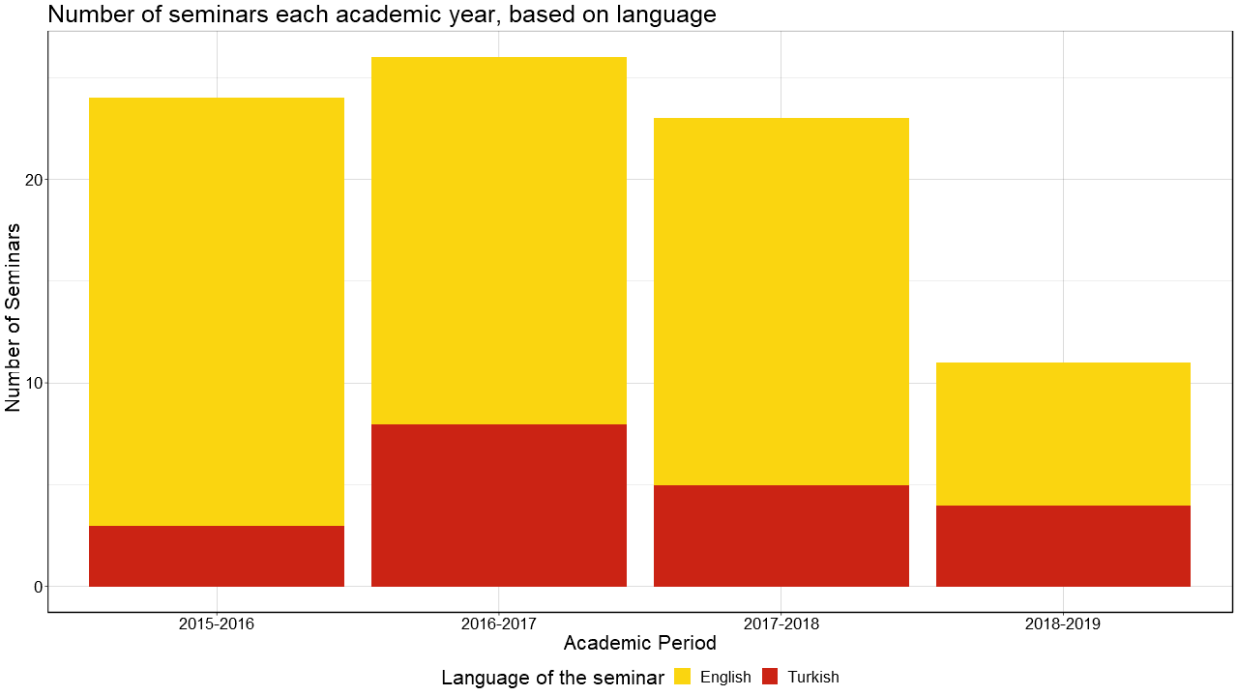
Figure 7. Seminars each academic year, based on language
Figure 7 shows that most seminars were given in English. Most amount of Turkish seminars were given in the 2016-2017 period.
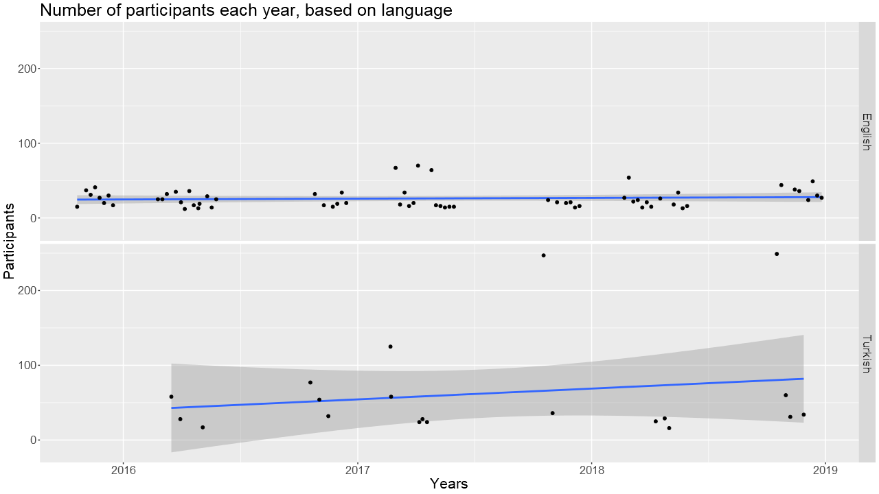
Figure 8. Number of participants each year, based on language
Figure 8 shows the LOESS linear regression lines, which for the Turkish case is a positively sloped curve.

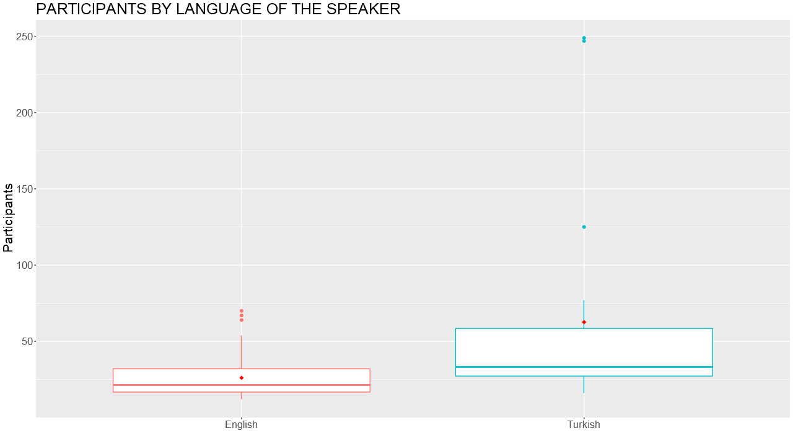
Figure 9. Participants by language of the speaker
Figure 9 shows the distribution of the participant numbers based on the language. As can be seen, while being in the minority, Turkish seminars attracted a wider range of participants overall.

Technical levels of the seminars
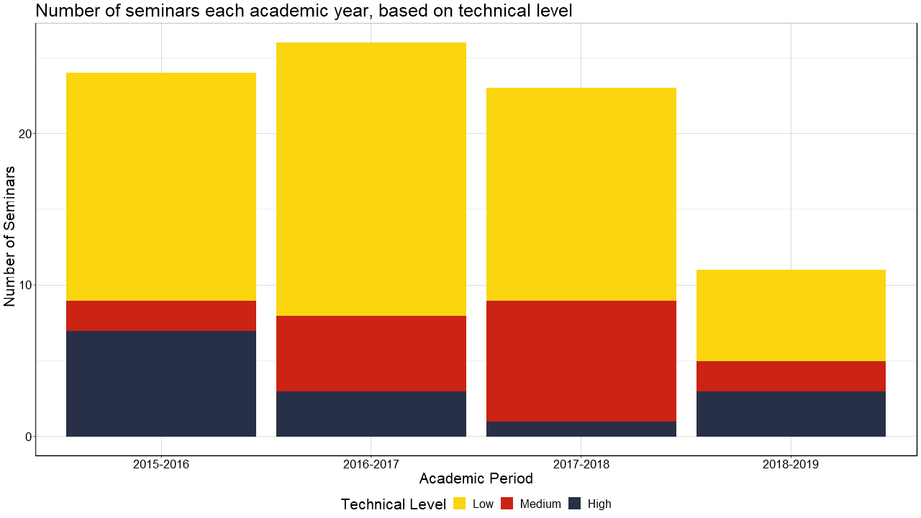 Figure 10. Seminars each academic year, based on the technical levels
Figure 10 shows that most seminars required low level of technical understanding, but medium level seminars are also increasing in number, given that the last period is only representing one semester.

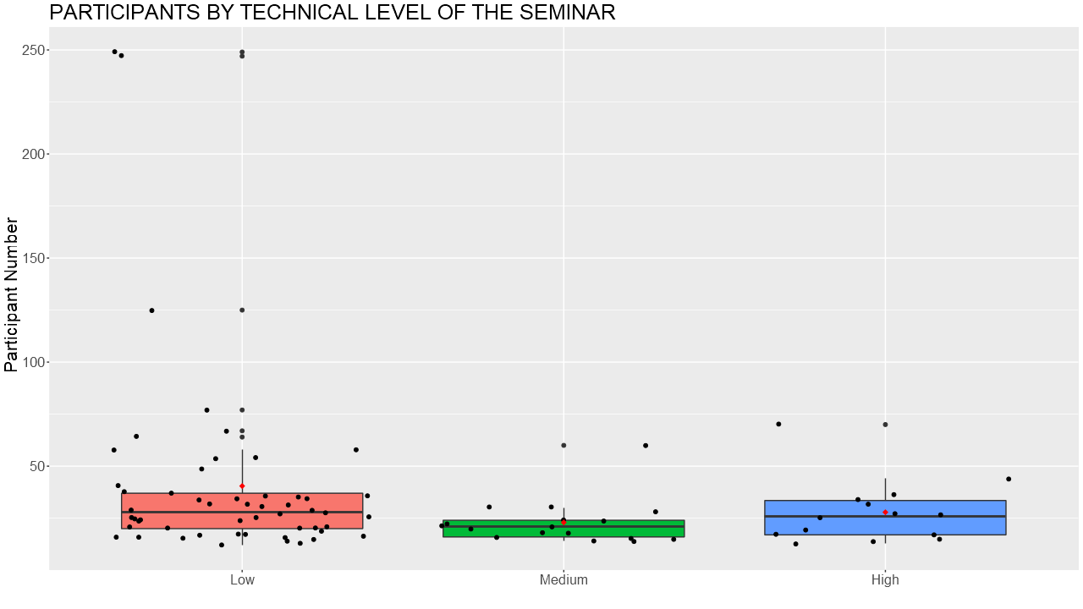
Figure 11. Participants by technical level of the seminar
Figure 11 shows the distribution of participant numbers across technical levels.

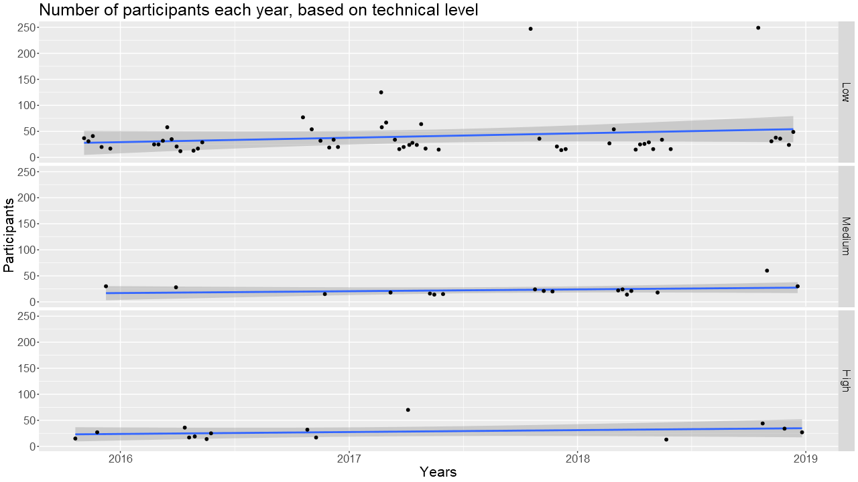
Figure 12. Participants each year, based on the technical levels
Figure 12 shows that while low technical level seminars were increasing in participation, medium and high remain mostly unchanged.

Academic programs
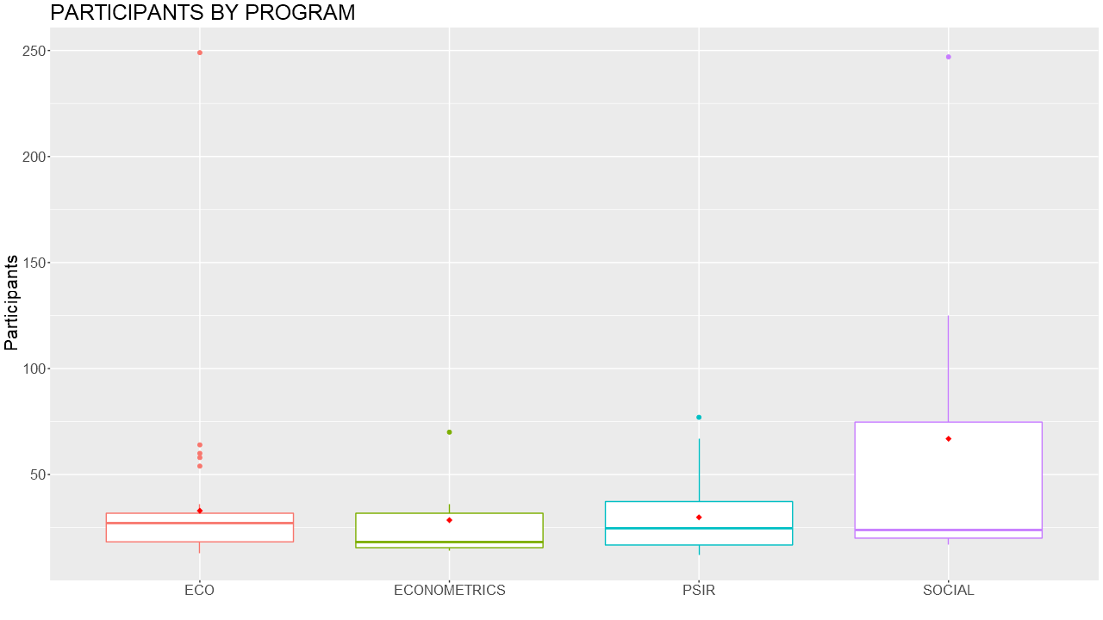
Figure 13. Participants of programs
Figure 13 shows the distribution of seminars in terms of programs. Social is a broader category with fewer seminars, but higher variability in the participant numbers. The other programs look similar, with economics having the most outliers.

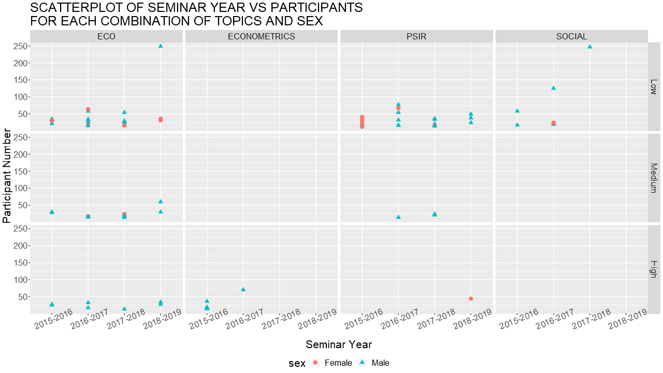
Figure 14. Scatter plot of seminar year vs participants for each combination of topics and sex

Figure 14 shows participant numbers over time for different programs and technical level, as well as the sex of the speaker. Talking about technical levels for a moment, all Econometrics topics were high level, and all social topics were low level. Economics (ECO) has the most spread in all three technical levels, followed by Political Science and International Relations (PSIR). Also, regarding sex, only one female speaker gave a high technical level seminar.

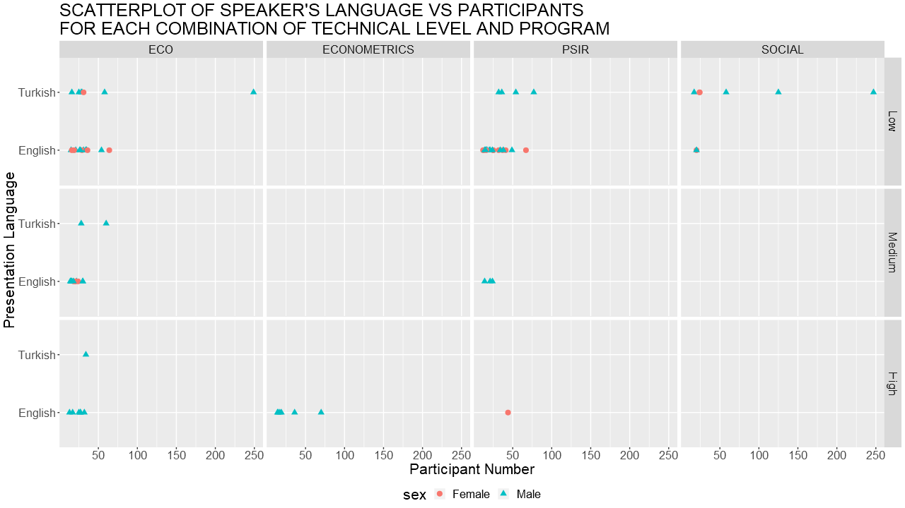
Figure 15. Scatter plot of the speaker’s language vs participants for each combination of technical level and program
Figure 15 shows the allocation of each seminar in terms of its language, sex, and the program it was in. As you can see, most of the clustering is in ECO and PSIR programs, held in English. While most other quadrants are dominated by men, in these two narrow slices, men and women seemed to have similar numbers of participations overall, and a similar number of seminars given.

Regions concerned
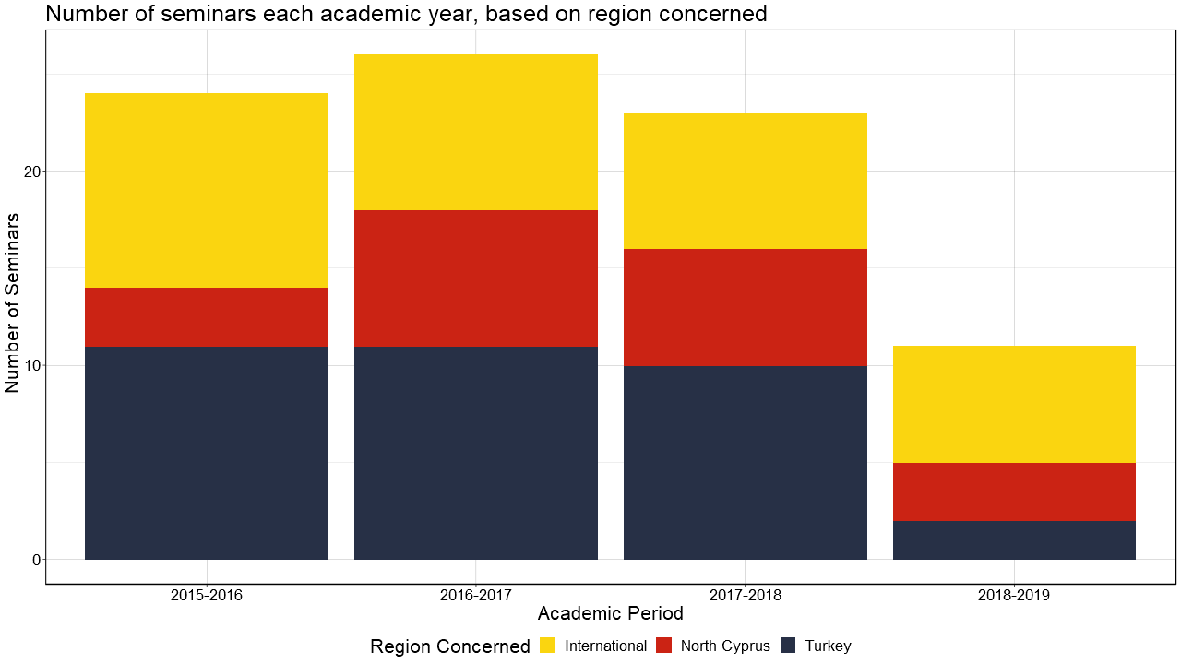
Figure 16. Seminars each academic year, based on region concerned
Figure 16 shows that most international subjects and subjects regarding Turkey are similar in size, despite the language gap. Meanwhile, the North Cyprus region got the least attention in the form of seminars.

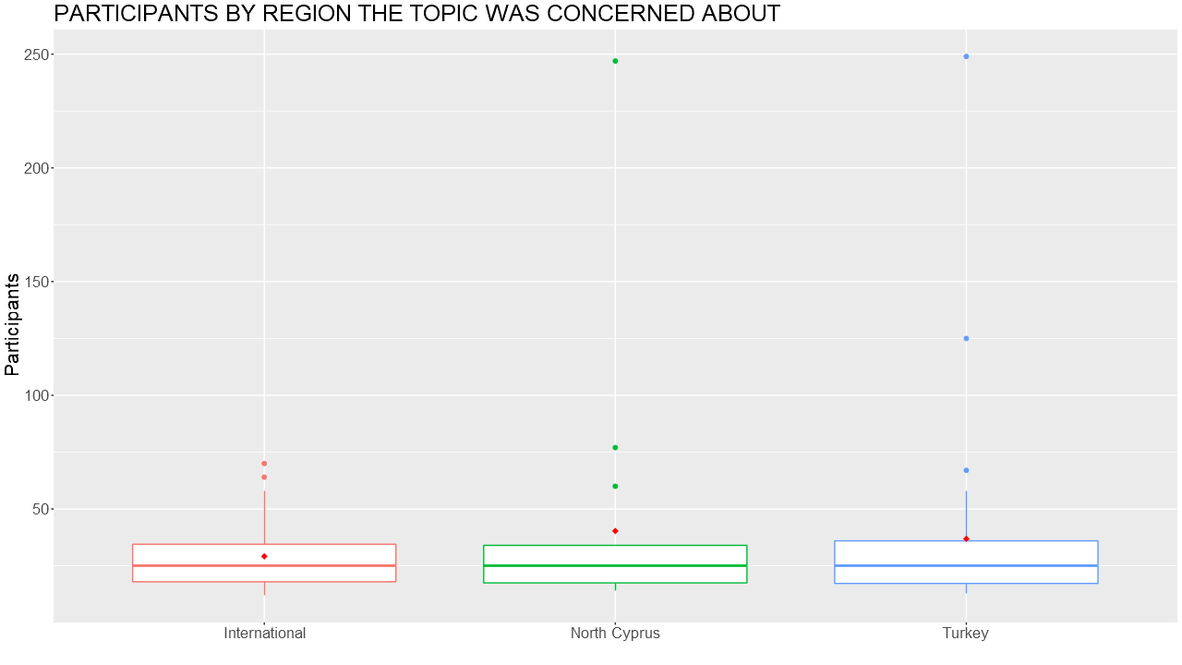
Figure 17. Participants by region the topic was concerned about
Figure 17 shows the distribution of participants along the three categories. While the distributions are close to each other, despite the under representation, seminars about North Cyprus has had considerable participation, even garnering 250 participants at one point when the President of TRNC talked about the ongoing Cyprus issue.

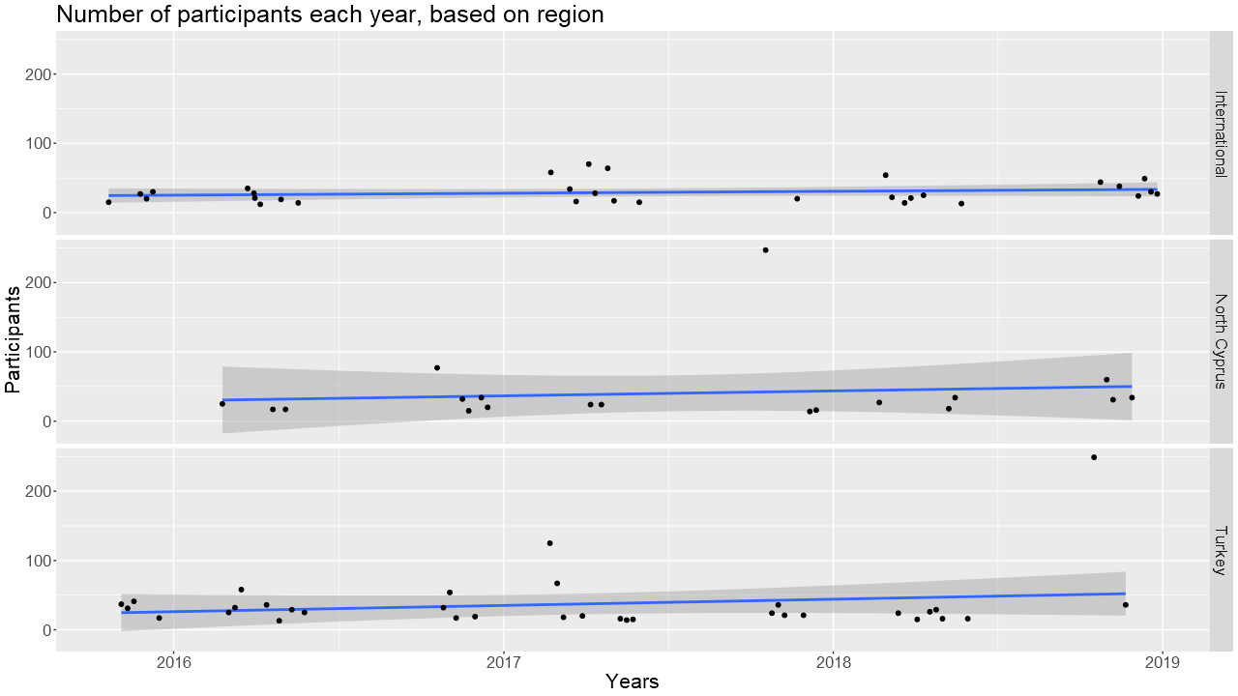
Figure 18 Number of participants each year, based on region
Figure 18 shows that while topics about international matters have a stable participation amount, other two categories have a slight increase over the years.

Thanks to;
Volga Sezen for his contribution in this report of a statistical analysis of the 2015-2018 academic years,
Mehmentcan Oralalp for his contribution in the previous report of a statistical analysis of the 2015-2016 academic year,
Merve Balcı and Özen Altın for recording this database and maintaining it,
The Economy and Finance and Socialist Thought Societies and their members for their dedicated work in keeping this series running with me.

