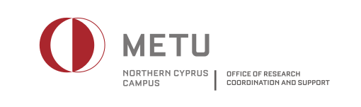

Application Form to Conduct Research at METU NCC
Please submit the form to the Office of Research Coordination and Support.

A. Applicant
1. Name :
2. Title :
3. Affiliation :
4. Address :
5. E-mail :
6. Phone :
7. Date :

B. Research Project
1. Title :
2. Topic :

C. Questionnaire to be used in the study
1. Who will be the participants for the questionnaire and how were they selected? Please describe the sampling methodology employed in the selection of participants and specify the size of the sample in the study.

2. When will the questionnaire be administered at METU NCC?

3. From which groups will the data be collected at METU NCC (staff, undergrad students, etc.) and how was the number of participants in each group estimated?

4. How will the questionnaire be administered at METU NCC? Please indicate how the participants will be expected to respond to the questionnaire (e.g., through face-to-face interviews, telephone or e-mail, etc)?

5. What is the expected response rate in the study? Please also describe the methodology to be employed to obtain this rate.

D. Data protection and privacy
1. Will any type of personal data be collected within the framework of the study? If yes, how will the confidentiality of the personal data be ensured?

2. Where and for how long will the data be stored?

3. Who will be entitled to access the collected data?

4. Will METU NCC academic staff be allowed to obtain the collected data for research purposes?

5. Will any personal information be reported in any report or publication using the collected data? If yes, what type of information will be reported?

6. Will information related to METU NCC be reported in any report or publication using the collected data? If yes, what type of information will be reported?

E. Dissemination of the findings
1. Who will the findings be shared with and how will they be publicized (e.g., report, thesis, paper, etc)?

2. Will METU NCC Administration and the participants be informed of the findings of the study? If yes, how will they be informed?

3. Who will potentially benefit from the findings of this study?

4. How will the METU NCC community potentially benefit from the findings of this study?

